|  |  |
| --- | --- |
| Event 2 go  Final Documentation | **Abstract**  Cross platform event management application designated for iOS, android and website users  **Prof: Jeff Fortuna**  Developers: Sanket Patel, Thomson Philip |

**Table of Contents**

Project Objectives1

Functional requirements2

Success criteria6

Site Map6

Database Design14

Site Maintenance14

Tech Stack 14

Tech Experience 15

**Project Objectives**

**The following describes the project to be executed.**

|  |  |
| --- | --- |
| **Objective** | The main objective of this project is to create a functional event management app that will have cross platform support for iOS, android and web applications |
| **Goals Addressed** | The main goals for this project are:   * Working cross platform application features   + The users for iOS, android and web applications will be able to see real time event listing * Working user sign-up, log in & password reset   + The user will be able to sign up in the application     - The user will be signed up after an email verification     - If the phone number is already registered, the sign up will be cancelled     - Error will show if the password entered has invalid characters     - Error will show if the confirm password value does not match     - Username will be checked for uniqueness   + Login will only be accepted through registered username and password     - The logout option will only show if the user has logged in   + Password reset will be done via email     - The username for password reset should be registered in the database       * Error will be shown if the username is not registered * Working event creation, sign up, modification and deletion   + Users will be able to create events     - The event must have a name, location and time       * Error will be shown if the values are missing     - The event end time should not be lower or equal to current time   + Users will be able to modify the events the user created     - The event end time should not be lower or equal to current time   + User will be able to delete an event the user created     - The event is automatically deleted if the current time passes the end time * Working user profiles   + The user profile will only contain the users name, image, age, occupation, and about me profile * The image, occupation and about me profile will be optional |
| **Planned Start Date** | January 9, 2018 |
| **Planned End Date** | April 3, 2018 |

**Functional Requirements**

**Use case:**

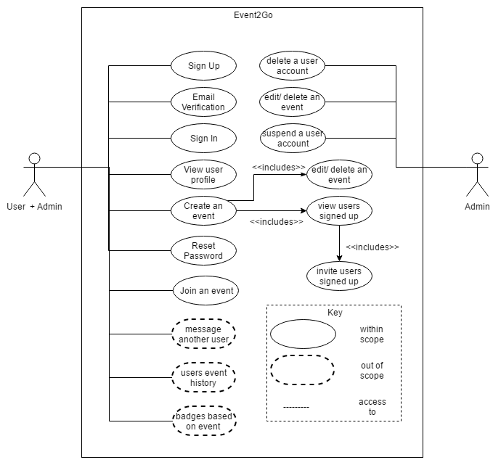

**State machine:**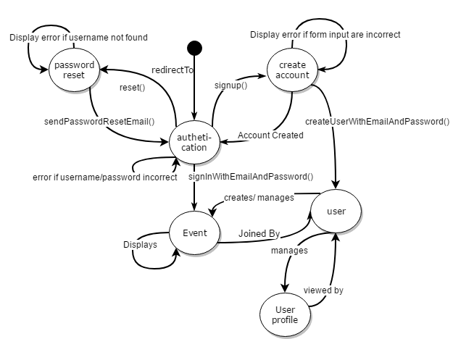

**Activity Diagram:**

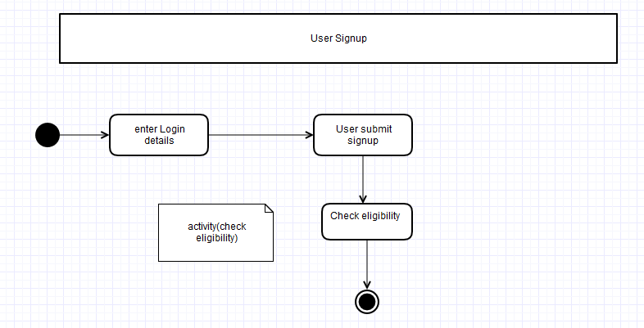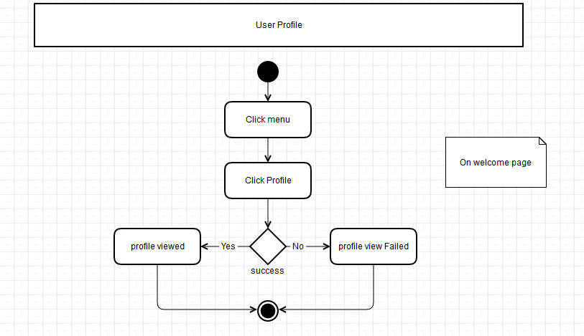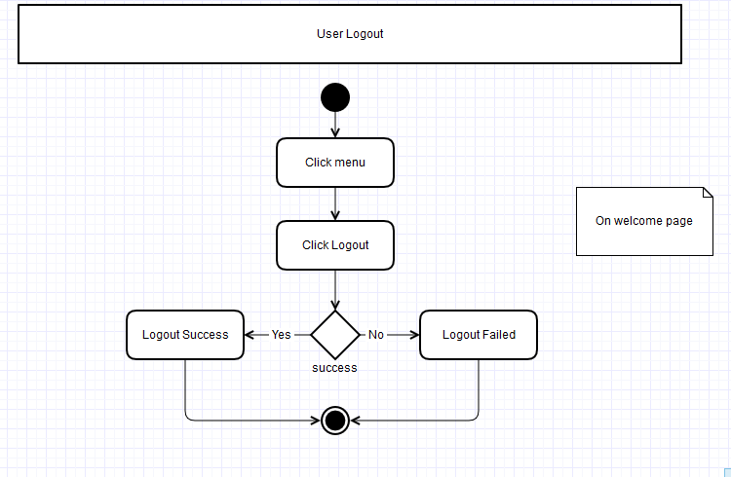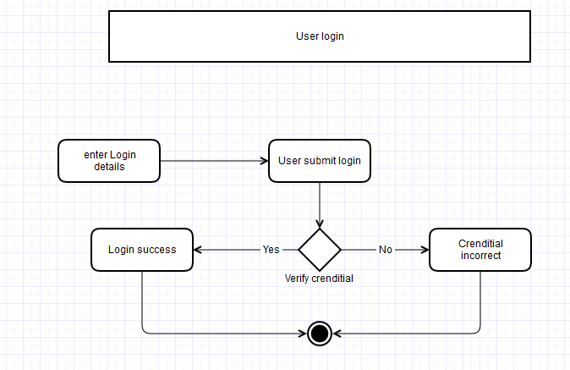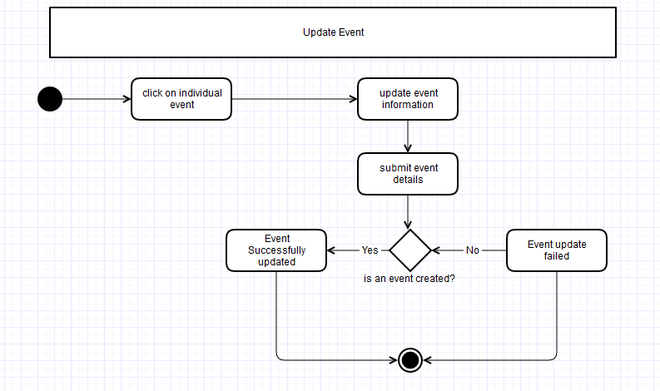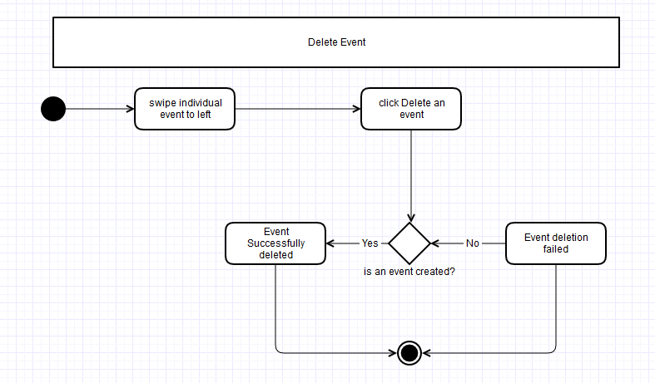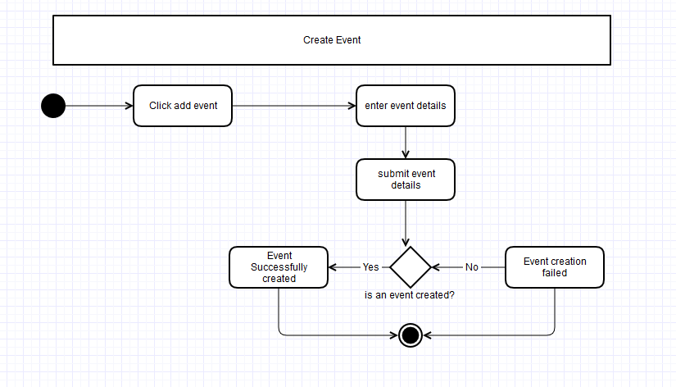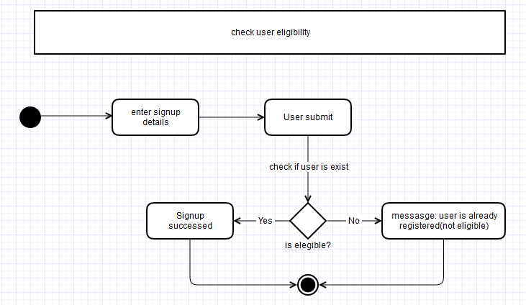

**Success Criteria**

The main success criteria considered for this application are:

* the cross-platform feature works as intended
* the user sign-up, log in and reset password functions work as intended
* the event creation, sign up and deletion features work as intended
* the user profiles work as intended

**Site Map**

**Sample site structure**

|  |  |
| --- | --- |
| * Login, Signup and Forgot password screen: | |
|  |  |
|  | |
| * Menu Screen: | |
|  |  |
| * Managing Event | |
|  |  |
|  | |
| * User Profile | |
|  |  |
| App view IOS |  |
| App view Android |  |
|  |  |

**Database Design**

* Entity Relationship Diagram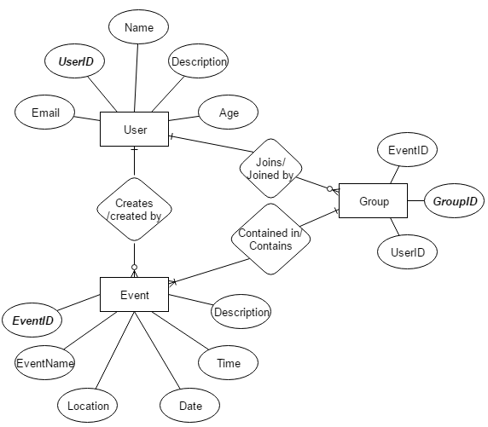

**Site Maintenance**

Phone gap would be used primarily to keep the testing servers up and the backend for the site will be maintained through firebase which has many features for example crash analytics and client data usage information.

**Tech Stack**

|  |  |
| --- | --- |
| **PhoneGap** | Cloud based software used for cross platform applications |
| **Sublime/ Visual Studio** | Code editor |
| **Firebase** | Backend |
| **GitHub** | Version Control |

**Tech experience**

PhoneGap:

|  |  |
| --- | --- |
| **Advantages** | **Disadvantage** |
| Open source | Background processing:  PhoneGap APIs are built using JavaScript which is not multi-threaded and hence do not support background processing. |
| Flexibility:  offers great flexibility as it can develop any type of mobile app without any serious efforts. Developers familiar with basic knowledge of HTML5, CSS3 and JavaScript can get started with PhoneGap |
| Compatible:  Provides uniformity when apps are developed for multiple platforms. | Data processing:  Native languages are much faster than JavaScript for data processing on the device. |
| Offline utilities:  provide offline functionality and has access to the browser’s local cache. |

Firebase:

|  |  |
| --- | --- |
| **Advantages** | **Disadvantage** |
| Optimized for real time applications | Cannot write structured queries, must search one query at a time |
| Being a hosted solution provides benefits like not having to maintain a server or spend effort scaling the app | No root access to location where data is stored |
| On a cloud so can be readily available anywhere | Hard to migrate to personal or secondary server, in case their server dies, or company falls out |
| Cross Platform API |

AngularJS:

|  |  |
| --- | --- |
| **Advantages** | **Disadvantage** |
| huge community to learn from | multiple ways to do the same thing, sometimes it can be hard to say which way is better for a task |
| AngularJS is more intuitive as it makes use of HTML as a declarative language. Moreover, it is less brittle for reorganizing. |
| range of other features that include Restful actions, data building, dependency injection, enterprise-level testing, etc. |